

Dear Friend of Galion Youth Baseball,

***THANK YOU*** for taking the time to consider sponsoring the Galion Youth Baseball program, a non-profit 501(c) (3) organization. We know that you receive many requests for sponsorships and donations, and we appreciate your consideration. Community support and sponsorships are an integral part of the success of our league. By supporting GYB, your business will gain exposure through the network of participants, families, friends, and other businesses associated with our program.

The GYB board believes that the months of April through July are an excellent opportunity to positively impact the youth of our community.  This past year, GYB had the opportunity to serve over 350 players, from T-Ball through the Babe Ruth, ranging from 4 to 16 years old. Our valued Sponsors allow us to meet the Little League mission; *developing the qualities of citizenship, discipline, teamwork and physical well-being. By espousing the virtues of character, courage and loyalty, our goal is to develop superior citizens rather than superior athletes.*

We are very proud of the achievements of the program in 2016. The 12U All Stars enjoyed its 4th straight District 7 Championship and went on to play in the State Tournament. The 11U All Star team made it to the District 7 championship game. The 10U team won the District 7 Championship and advanced to the State Tournament as well. Our 8U All Star teams played in several post season tournaments, including the Stewart Memorial 8U tournament played in Galion. In addition, Galion hosted the 11U District tournament in July which brought thousands of people to Heise Park for games.

On behalf of the Galion Youth Baseball, its participants, and families, please accept our gratitude. If you have any questions, please do not hesitate to contact me.

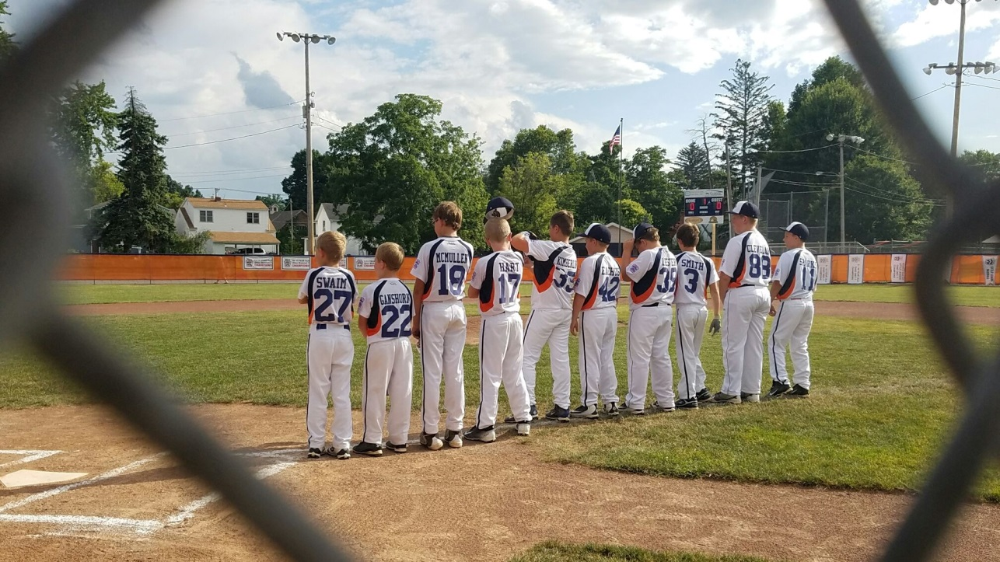We look forward to a fun, safe, and successful 2017

season.

Best Regards,

Justin McMullen

Galion Youth Baseball, President

Email: [galionyouthbaseball@yahoo.com](mailto:galionyouthbaseball@yahoo.com)

